Michael Osei

4/12/2023

COSC 480

Establish connection with SQL server



Inserting a new record

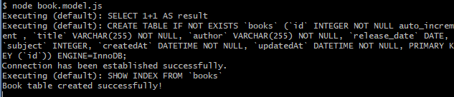

Viewing table in MySQL Database

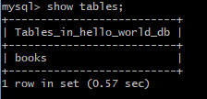

Selecting All Records and with Where clause

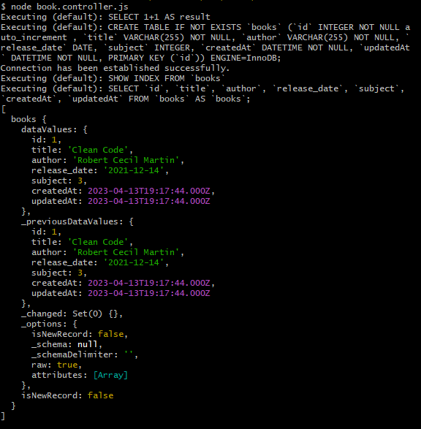

Delete Record

